# Lab: URL's and Templates

## Create new Django Project

Open the terminal and create **new Django project** as shown in the picture

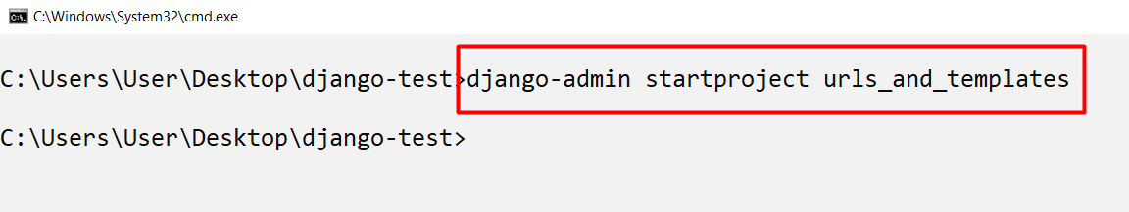

Navigate to the project folder and create **two apps**: **main_app** and **secondary_app**

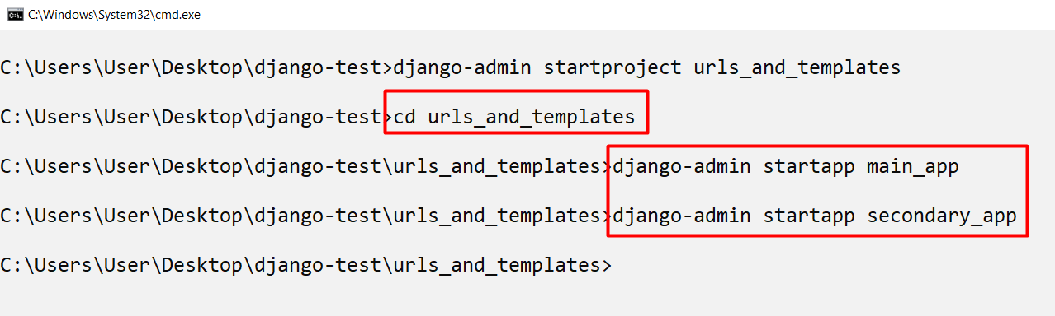

Now, we need to **add** our apps to the project **settings**

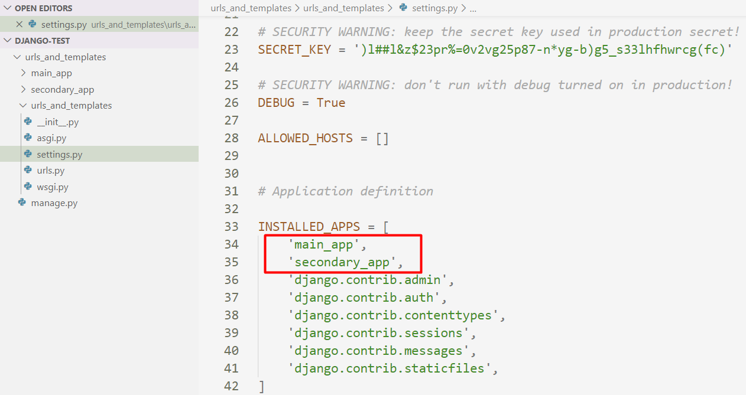

## Create all Templates

Let us now create a **template folder** with **two sub-folders** named after the apps. Each folder will contain an **index.html** file. At the end, the folder structure should look like this

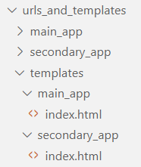

Now, we need to add the **templates directory** to our project **settings**

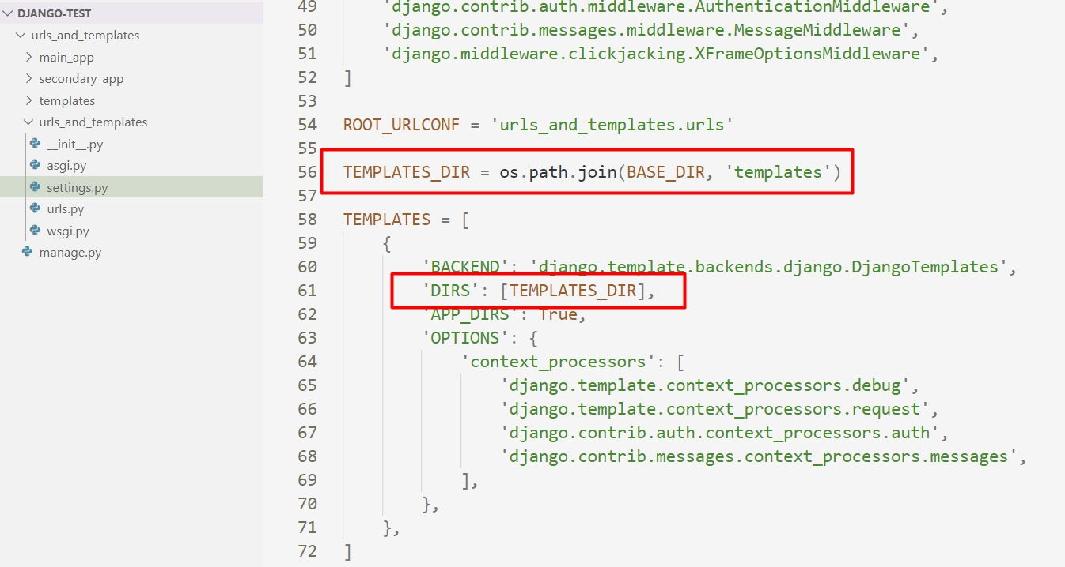

Now let us go to the main app **index.html** file and add the following code

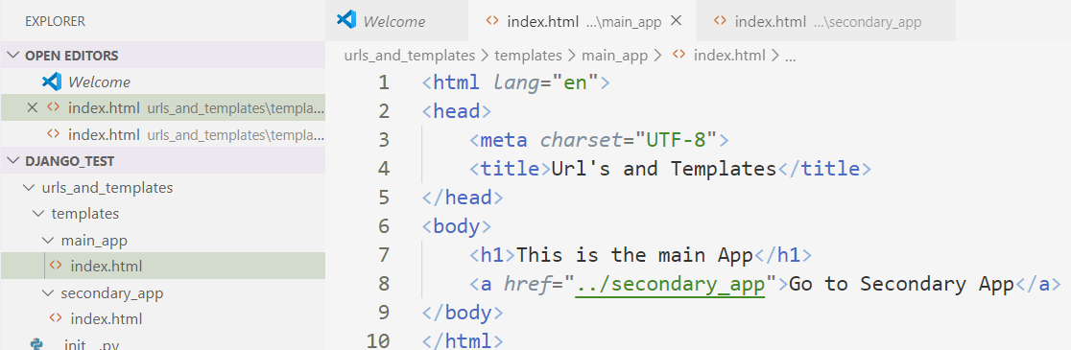

* We just add **h1** and a link to the **secondary_app**, so we can navigate between the two apps

In the **index.html** in the secondary app, add the following, so we can return to the **main app**

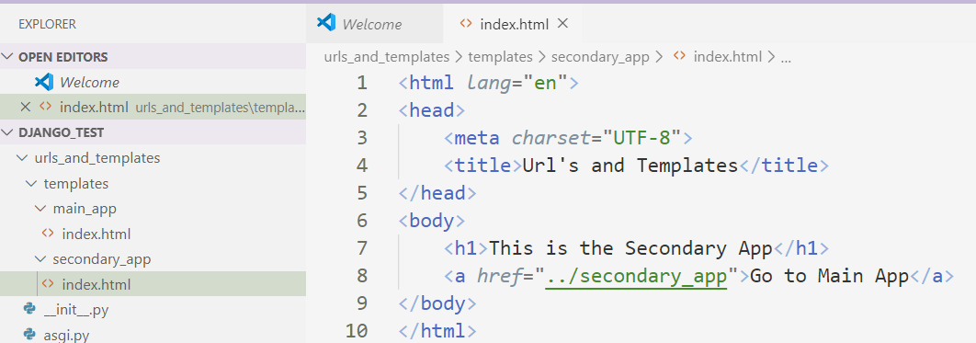

## Implement the views.py files

Now let us implement the **views** for both apps, starting with the **main app**. In there we are going to create a function called **index**, which will be responsible for rendering the **index.html** file

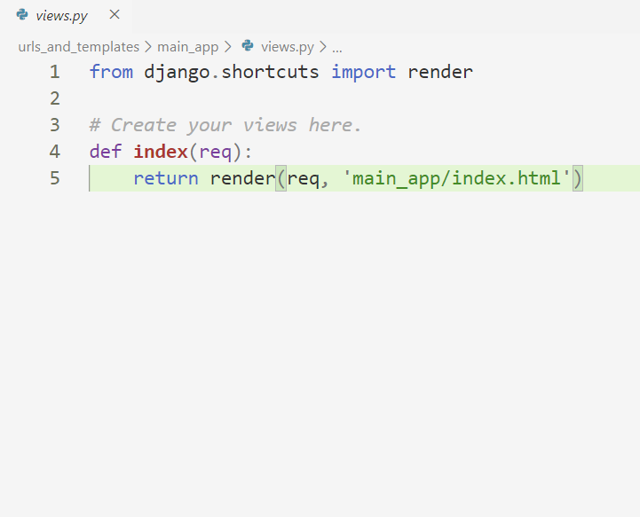

And then, the same for the **secondary app**

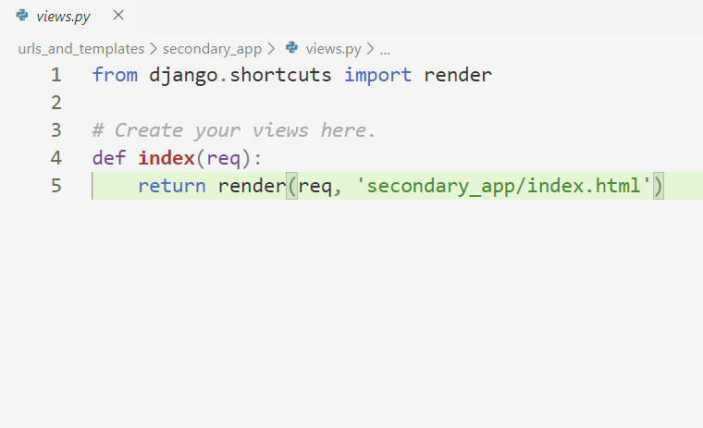

## Implementing the urls.py files

Now, for those functions to be executed, we need the **urls.py** files for both our apps. Since they are not automatically generated, we need to **create them**. So, let us start with the **main app**

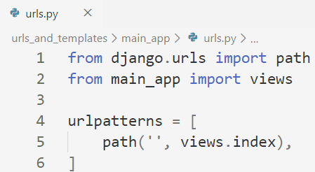

And then the **secondary app**

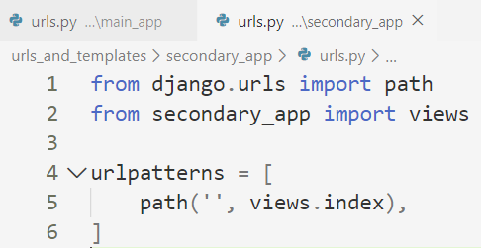

In both cases the path is **''**, because as soon as we hit **'main_app'** or **'secondary_app'** url's, we want to execute the **index** functions and render the **index.html** file

## Including the urls.py Files in the Project

Finally, we want to include those **urls.py** files in our project, so it knows about them

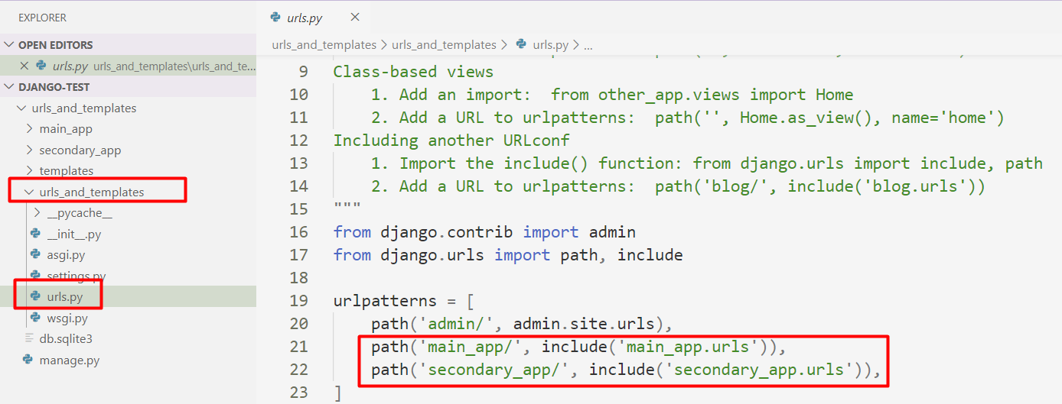

## Testing

Now, let us test the app by **running our project**

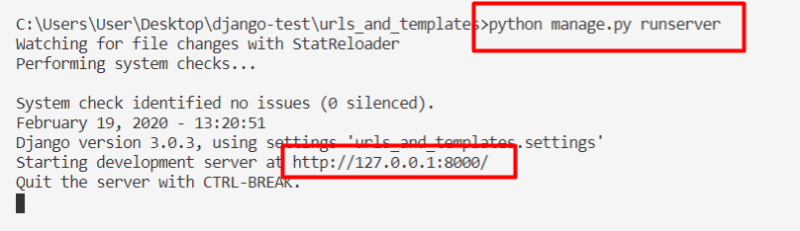

Now to see our main app, we need to navigate to <http://localhost:8000/main_app>

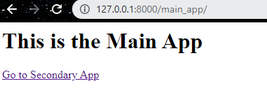

And if we click on the link, we will see the second app

